

**LA GRANDEE International College**

**Simalchaur, Pokhara Nepal**

A Project Report

on

**"NepHeal"**

**Submitted to**

LA GRANDEE International College

Bachelor of Computer Application (BCA) Program

In the partial fulfillment of the requirement for the degree of BCA affiliated to

Pokhara University

**Submitted by**

|  |  |  |  |
| --- | --- | --- | --- |
| **Name** | **Course** | **Semester** | **P.U. Registration Number** |
| Akriti Dhakal | BCA | 8th | 2021-01-53-0047 |
| Prashant Adhikari | BCA | 8th | 2021-01-53-0069 |
| Sushan Poudel | BCA | 8th | 2021-01-53-0090 |

**Date: 2025-05-08**

**Table of Contents**

1. Introduction 3

2. Problem Statement 5

3. Objectives 6

4. Background Study 7

5. Methodology 10

4.1 Process (Flow) Diagram 12

5. Project Gantt Chart 13

6. Deliverables 14

7. References 15

# 1. Introduction

NepHeal: Health On Your Schedule

In today’s healthcare system, scheduling a doctor’s appointment can be stressful, inefficient, and outdated. Whether you're a patient trying to find the right specialist or a hospital struggling to manage bookings, the lack of a proper digital system causes confusion, delays, and frustration. NepHeal is here to change that. It's an intuitive digital platform built to revolutionize how doctor appointments are handled in Nepal. With NepHeal, patients can easily browse available doctors, check their schedules, and book appointments with just a few taps—no more long waits, phone call follow-ups, or uncertainty about availability.

NepHeal is not just for patients; it’s also a valuable tool for hospitals and clinics. It allows staff to manage doctor schedules, patient queues, and appointment confirmations with ease. With features like patient history management and digital booking records, NepHeal offers a complete solution to modernize healthcare access. The platform includes a user-friendly mobile app and web portal for both patients and doctors, real-time appointment availability, notifications and reminders, doctor profiles with specialization and availability, and an admin dashboard for hospitals and clinics. These features work together to ensure a smooth and efficient experience for all users.

What sets NepHeal apart is its strong local focus, user-first design, and practical features that align with Nepal’s current digital capabilities. The platform is built for hospitals, clinics, and individual practitioners, ensuring seamless coordination between all users. Whether you are a patient, a doctor, or a healthcare institution, NepHeal simplifies the entire process and makes healthcare access more reliable and efficient.

“To simplify healthcare access in Nepal by providing a reliable, efficient, and user-friendly doctor appointment system.”

# 2. Problem Statement

In today's fast-paced world, accessing healthcare should be quick and easy, but many people in Nepal still face challenges when it comes to booking doctor appointments. The current systems for scheduling appointments are outdated, inefficient, and lack the transparency patients need to feel confident about their healthcare choices.

* Manual booking systems causing delays and overbookings
* Lack of real-time information on doctor availability
* No centralized patient record, leading to repeated diagnostics
* Long queues and wait times, wasting valuable time for both patients and staff

# 3. Objectives

The key objective of the NepHeal is:

* To develop a digital platform for efficient, real-time doctor appointment booking and management.
* To create a mobile-first system for both patients and doctors
* To automate appointment schedules and reduce manual errors
* To implement reminder systems to reduce no-shows
* To provide hospitals and clinics with an admin dashboard to manage bookings
* To build a user-friendly and secure patient-doctor communication flow

# 4. Background Study

In today’s rapidly evolving world, access to healthcare should be simple and efficient. However, in Nepal, the traditional systems for booking doctor appointments remain outdated, often leading to confusion, delays, and frustration for patients. Manual methods such as phone calls, in-person registrations, and handwritten appointment books are still widely used in many clinics and hospitals, which results in overbookings, miscommunications, and loss of patient data.

**Challenges in Nepal’s Healthcare Booking System:**

1. **Manual Booking Systems**: Many clinics still rely on phone calls or in-person visits to schedule appointments, leading to time-consuming processes and scheduling errors.
2. **Limited Access to Real-Time Information:** Patients often struggle to get accurate and up-to-date information about doctor availability, causing uncertainty and unnecessary delays.
3. **Lack of Centralized Patient Records:** Without a unified system to manage patient history and appointments, patients must repeat diagnostic tests and provide the same information multiple times.
4. **Long Wait Times and Inefficiency:** Clinics and hospitals that rely on manual systems experience long queues, wasting both patient and staff time.
5. **Missed Appointments:** Without appointment reminders or a proper tracking system, patients frequently miss their appointments, causing disruptions in both their care and the hospital's operations.
6. **Limited Local Reach:** Existing platforms like MeroDoctor and HamroDoctor cater mostly to larger urban clinics and hospitals, leaving smaller local practitioners out of the digital healthcare ecosystem.

**Current Digital Health Solutions:**

* **MeroDoctor and HamroDoctor:** These platforms offer online bookings and teleconsultation for major hospitals, but they don’t cover smaller clinics or individual practitioners, making them inaccessible to a significant portion of the population.
* **HealMe Nepal:** This platform lists doctors and allows users to contact clinics directly, but it still requires manual calls for booking and payments at hospitals, which undermines its convenience.

Despite the availability of some digital solutions, these platforms don’t fully meet the needs of the Nepali population, particularly in rural areas where internet connectivity and technological infrastructure are still limited.

The Need for NepHeal: A Localized, Affordable, and User-Friendly Solution

NepHeal aims to address these challenges by providing a comprehensive, digital doctor appointment platform tailored to Nepal's healthcare needs. Unlike existing solutions that either cater to larger clinics or rely on phone calls, NepHeal is designed for a wide range of healthcare providers, including small clinics and local practitioners.

The platform simplifies appointment booking by offering real-time doctor availability, appointment reminders, and easy access to patient records. It is specifically created to address the local infrastructure challenges in Nepal, offering a mobile-friendly solution to users who may not have regular internet access.

With NepHeal, patients can quickly find the right doctor, book appointments online, and manage their healthcare needs all from one platform. The app is designed to be simple and easy to navigate, ensuring that even users with limited digital literacy can benefit from its features. The platform also offers appointment tracking, reducing missed visits and improving communication between patients and healthcare providers.

NepHeal’s localized approach ensures that it fits within the infrastructure of Nepal’s healthcare system, providing an efficient, reliable, and accessible service for all.

# 5. Methodology

The project will follow an Agile, iterative development approach. Agile methodology (Scrum) is well-suited for projects like NepHeal because it allows the team to implement key features quickly and refine them based on feedback. In Agile, the development is broken down into short sprints where a subset of functionality is completed, reviewed, and improved in cycles.This ensures continuous progress and flexibility in incorporating user feedback.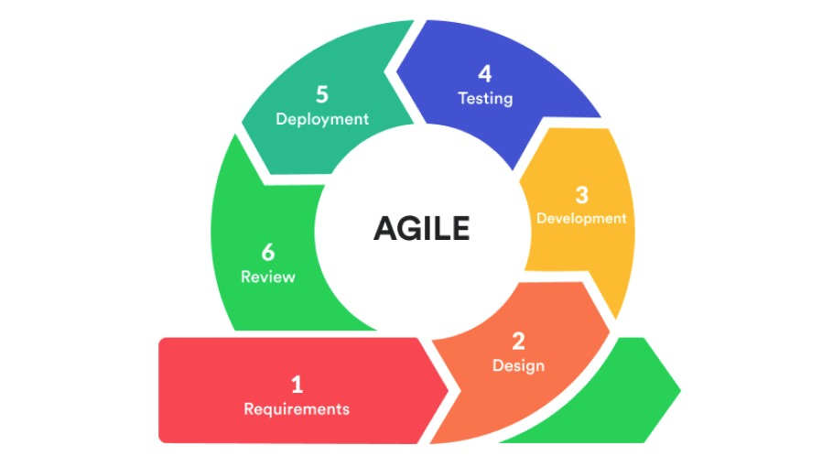

Figure 1: Agile Methodology

* **Requirements:** In this phase, our team defines the requirements for an efficient image filtering application by identifying market gaps in existing software solutions. We evaluate the resources, time, and effort needed for development, while also assessing both technical and economic feasibility.
* **Design :**Using system design tools such as Data Flow Diagrams (DFD), Entity-Relationship (E-R) diagrams, and flowcharts, we build a conceptual model of the application. This model serves as the foundation for development, ensuring clarity and structure.
* **Development:** Initially, development focuses on core functionalities like cropping, blurring, and basic filters, prioritizing simplicity and performance. These features are iteratively improved in subsequent sprints to enhance usability and functionality while maintaining optimal performance.
* **Testing:** Rigorous testing is conducted to validate the application's performance, functionality, and stability. Bugs and issues are identified and resolved promptly, ensuring the software meets high-quality standards and delivers a seamless user experience.
* **Deployment:** The finalized version of the application is deployed into users' environments. We ensure compatibility across different systems and provide necessary support to facilitate smooth integration and usage.
* **Review:** Post-deployment, we evaluate the application's usability and effectiveness. Feedback from users is used to make iterative improvements, addressing any shortcomings and continuously enhancing the system.

## Data Flow Diagram (DFD)

A Data Flow Diagram (DFD) is a visual tool used to show how data moves through a system. It highlights how inputs are collected, processed, and how outputs are delivered, making it easier to understand the system’s structure and flow of information.

The following Level 0 Data Flow Diagram (DFD) provides an overview of the NepHeal Doctor Appointment System, showing the interaction between key entities such as patients, doctors, and administrators. It illustrates how data flows during important activities like user registration, appointment booking, viewing doctor availability, and system management.

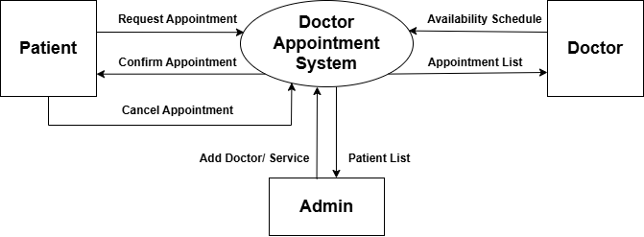

Figure 1: DFD Level 0

# 5. Project Gantt Chart

A Gantt chart compares the quantity of work or production that has been performed over a period of time to the amount that was anticipated during those times using a series of horizontal lines.

Following is the Gantt chart of NepHeal.

|  |  |  |  |  |  |  |
| --- | --- | --- | --- | --- | --- | --- |
| SDLC | April | | May | | June | |
| Analysis |  |  |  |  |  |  |
| Design |  |  |  |  |  |  |
| Coding |  |  |  |  |  |  |
| Testing |  |  |  |  |  |  |
| Maintenance |  |  |  |  |  |  |
| Documentation |  |  |  |  |  |  |

Fig2: Project Gantt chart

# 6. Deliverables

After a system is created, there are certain expectations to be fulfilled by it for it to be called a successful system. Even though one system can never quite fulfill all the requirements or criteria of every single employee and there are some criteria that can be lifted fulfilled.

* + - A mobile and web-based application for patients and doctors
    - Real-time booking engine with smart time-slot management
    - Secure login and appointment reminder notifications
    - Admin dashboard for hospitals to manage bookings and view analytics
    - Encrypted cloud-based patient record storage
    - A feedback and rating system for improving service quality

# 7. References